8086 SAMPLE PROGRAM — BUILD AND RUN GUIDE
Reading two numbers from the keyboard, computing their sum, and printing the result to the console
Microprocessor Systems — Laboratory Handbook
Content | Details
Processor | Intel 8086 (16-bit)
Emulator | emu8086 version 4.08rt
Program model | COM — one 64 KB segment, entry point at offset 100h
Source file | testcong.asm
Working folder | C:\emu8086\MyBuild
DOS services used | INT 21h / AH = 1 (read one character, with echo)  INT 21h / AH = 2 (write one character)
Accepted input | one digit per number, 0 to 9
Result range | 00 to 18, always printed as two digits

1. Creating the Project
Step 1. Start emu8086 and choose “new”
The opening dialog offers a list of templates. Do not dismiss it — the template decides how the file begins, and choosing the wrong one produces errors that look like syntax mistakes.
Step 2. Select the COM template
The COM model keeps code, data and stack inside a single 64 KB segment. Nothing has to be declared: no .MODEL, no .STACK, no .DATA, and no setting up of DS at the start. The program simply begins at offset 100h and ends with ret. The EXE model separates those segments and earns its keep once a program grows large, but for thirty lines it only adds ceremony.
The template inserts the line org 100h automatically. That directive tells the assembler the first instruction will sit at offset 100h, because DOS reserves the 256 bytes below it for the Program Segment Prefix.
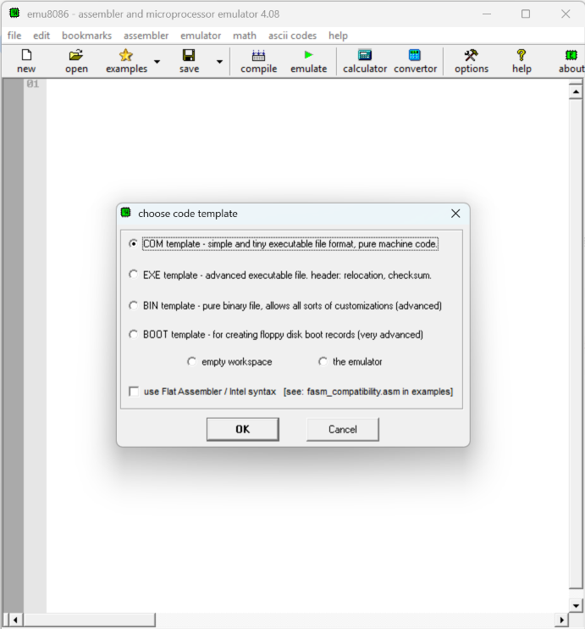
Figure 1. The emu8086 template chooser, with COM template selected
Step 3. Save the file as testcong.asm
Save into C:\emu8086\MyBuild. Everything the compiler produces later lands in the same folder, so keeping the source there keeps the whole exercise in one place.
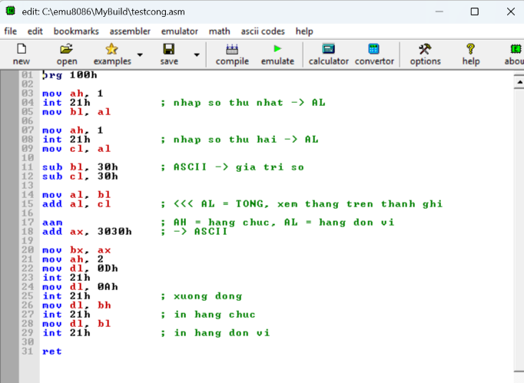
Figure 2. The source code in the emu8086 editor after saving as testcong.asm

2. The Program
The listing below is the complete source. Comments inside the file are written in Vietnamese; the walkthrough that follows explains each block in English.
org 100h

mov ah, 1
int 21h ; nhap so thu nhat -> AL
mov bl, al

mov ah, 1
int 21h ; nhap so thu hai -> AL
mov cl, al

sub bl, 30h ; ASCII -> gia tri so
sub cl, 30h

mov al, bl
add al, cl ; <<< AL = TONG, xem thang tren thanh ghi

aam ; AH = hang chuc, AL = hang don vi
add ax, 3030h ; -> ASCII

mov bx, ax
mov ah, 2
mov dl, 0Dh
int 21h
mov dl, 0Ah
int 21h ; xuong dong
mov dl, bh
int 21h ; in hang chuc
mov dl, bl
int 21h ; in hang don vi

ret

How it works, block by block
# | Instructions | What happens
1 | mov ah, 1  int 21h  mov bl, al | DOS service 01h waits for a keypress, echoes it on screen, and returns its ASCII code in AL. The code is copied into BL at once, because the next read will overwrite AL.
2 | mov ah, 1  int 21h  mov cl, al | AH is loaded again before the second read so that each read is self-contained. Relying on AH surviving a DOS call is a habit that breaks the moment a different service is used.
3 | sub bl, 30h  sub cl, 30h | The keyboard delivers character codes, not values: the key 3 arrives as 33h. Subtracting 30h — the code of the character 0 — turns the code into the number it depicts. Skip this and the program adds 33h to 34h and returns 67h.
4 | mov al, bl  add al, cl | AL now holds the sum, somewhere between 0 and 18. It is a number at this point, not something that can be printed.
5 | aam | AAM divides AL by 10 and leaves the quotient in AH and the remainder in AL — the tens digit and the units digit. That is exactly the split a two-digit number needs before it can be printed.
6 | add ax, 3030h | Adding 3030h to the whole of AX adds 30h to AH and 30h to AL in a single instruction, because the two digits happen to occupy the two halves of one register.
7 | mov bx, ax | Service 02h reads the character to print from DL and nowhere else, and DL is about to be reused four times. The digit pair is parked in BX first.
8 | mov ah, 2  mov dl, 0Dh  int 21h  mov dl, 0Ah  int 21h | 0Dh (carriage return) moves the cursor back to column 1; 0Ah (line feed) moves it down one line. Both are needed — a carriage return on its own would print the result on top of the digits just typed.
9 | mov dl, bh  int 21h  mov dl, bl  int 21h | BH holds the tens digit and BL the units, both already converted to ASCII in step 6.
10 | ret | In the COM model, ret returns control to the operating system.

3. Compiling
Step 4. Click compile
emu8086 asks where to save the compiled output; keep the default folder, C:\emu8086\MyBuild. If the source contains no errors the status line reports a successful build and five files appear.
File | What it holds
testcong.com_ | The machine code itself, ready to be loaded at offset 100h. This is the compiled program.
testcong.com_.list | Address, machine code and source line side by side. Useful for seeing how many bytes each instruction became.
testcong.com_.symbol | The symbol table.
testcong.com_.debug | Information the emulator uses to step through the source.
testcong.com_.~asm | A copy of the source exactly as it stood at compile time.
emu8086 writes the extension with a trailing underscore. A 64-bit version of Windows cannot run a 16-bit COM file directly in any case — the program is meant to be run inside the emulator.
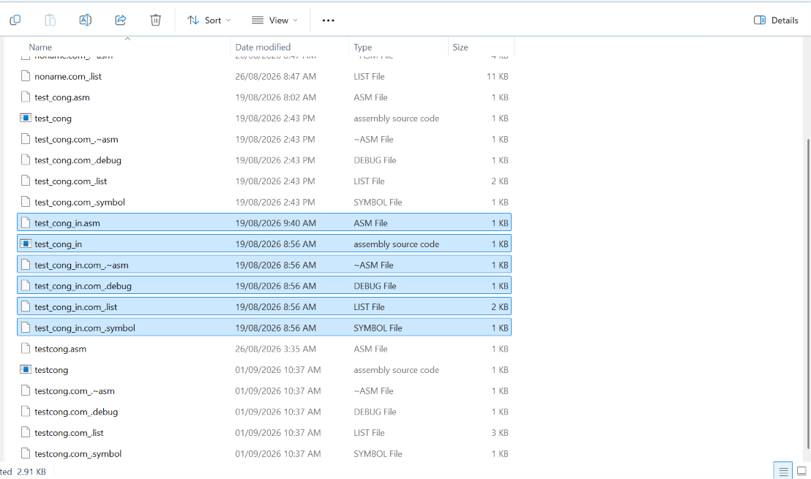
Figure 3. The C:\emu8086\MyBuild folder after compiling, showing the testcong.com_ files

4. Running
Step 5. Click emulate
The emulator window opens with the program loaded. Before anything runs, IP reads 0100h — the offset the org directive set — and the register panel shows the starting state.
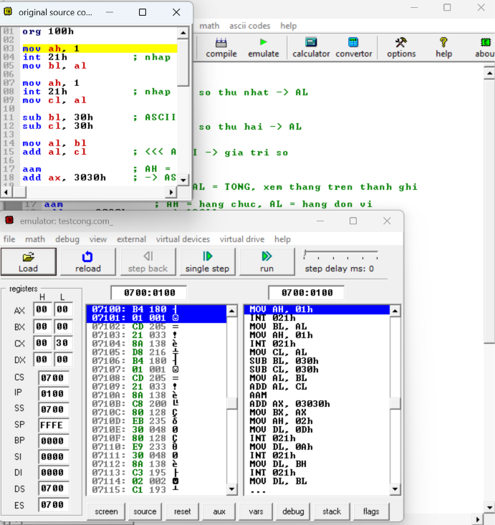
Figure 4. The emulator window with the program loaded, before running
Step 6. Click run, then type two digits
A separate console window appears — the black window the exercise refers to. Each digit is echoed as it is typed, because service 01h echoes by design. After the second keypress the program prints the result on the next line and returns.
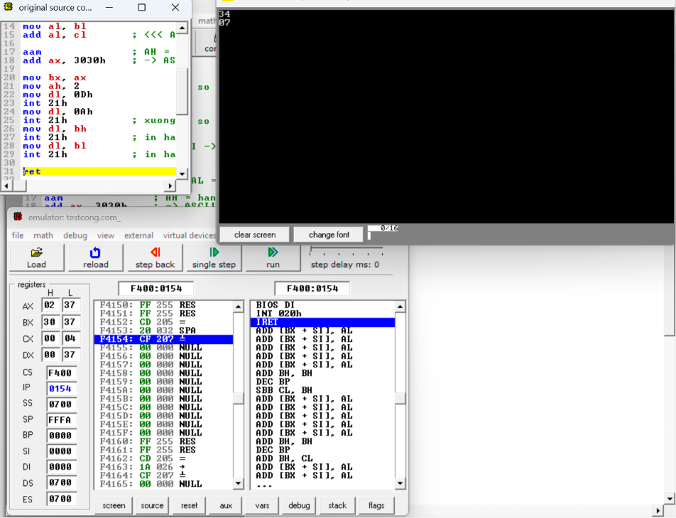
Figure 5. The console window showing the two digits typed and the result on the line below

5. Result
Typing 3 and then 4 produces the following sequence:
After | Register | Value | Meaning
first read | BL | 33h | the code of the character 3
second read | CL | 34h | the code of the character 4
the two sub | BL, CL | 03h, 04h | the numbers themselves
add al, cl | AL | 07h | the sum
aam | AH, AL | 00h, 07h | tens digit, units digit
add ax, 3030h | AX | 3037h | the characters 0 and 7
mov bx, ax | BH, BL | 30h, 37h | parked, ready to print
The console shows:
34
07

The first line is the echo of the two keypresses; the second is the result. A second run with 9 and 9 gives AL = 12h, which AAM splits into AH = 1 and AL = 8, so the console prints 18.

6. Verification
- The status line reports the build finished with no errors.
- Five files named testcong.com_* appear in C:\emu8086\MyBuild.
- The emulator opens with IP = 0100h before the first step.
- The console accepts exactly two keypresses and echoes both.
- The result appears on the following line and matches the sum worked out by hand.

7. Troubleshooting
Symptom | Cause | Fix
The result is a letter or a punctuation mark | The two ASCII codes were added without being converted to numbers first | Check that both sub instructions are present and run before the add
One strange character appears instead of two digits | AL was printed directly, without the AAM and 3030h conversion | Restore the aam and add ax, 3030h pair
Sums of 10 or more come out as a single character | Same cause — without AAM only one half of the value is printed | Same fix
The result overwrites the digits just typed | Only 0Dh was sent, so the cursor returned to column 1 but stayed on the same line | Send 0Ah immediately after 0Dh
The console accepts only one keypress | AH was not set back to 1 before the second read | Add mov ah, 1 before the second int 21h
No console window appears | The program was compiled but never emulated | Click emulate, then run
An error is reported on the very first line | The file was created without the COM template, so org 100h is missing | Recreate the file from the COM template and paste the code back in

8. Known Limitations
- Each number is a single keypress, so only 0 to 9 can be entered. A sum such as 12 + 5 is out of reach.
- The result is always printed with two digits, so a sum of 7 appears as 07.
- There is no validation. Pressing a letter is accepted and yields a meaningless result, because the program subtracts 30h from whatever code arrives.
- Accepting multi-digit input would need a loop that reads characters until Enter and accumulates ax = ax * 10 + digit. That is the natural next exercise.

